Heavenly Blessings Day School @ First Baptist Church
Program and Policies Parent Handbook

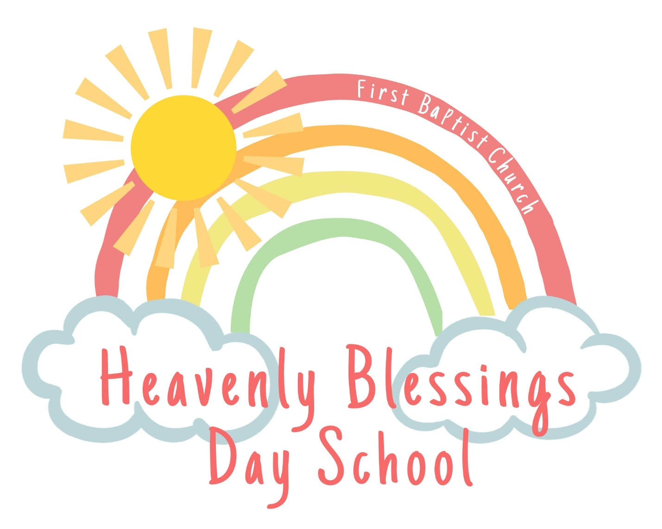

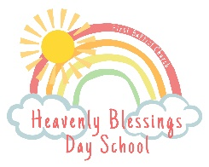
Heavenly Blessings Day School
@ First Baptist Church – Navasota, Texas
Program and Policies Parent Handbook

Tuesday/Wednesday/Thursday 8:30 A.M. – 12:30 P.M. (2:30 P.M. Stay and Play)

Purpose
This handbook’s purpose is to inform parents of school policies and program information. Parents will be given a new copy each year and will be informed of changes to policy in writing when they occur throughout the year. Parents are expected to read and be familiar with the document’s information, and the document serves as the parent contract. The “Acknowledgement of Programs and Policies Handbook”, which is the last page of this document, must be signed and returned by the first day of enrollment.
Statement of Mission and Vision
Mission
The mission of Heavenly Blessings is to provide a safe and loving environment where children grow solid spiritual and educational foundations.
Vision
We will provide interactions with students and their parents which display Christ-like characteristics.
We will provide a variety of age-appropriate developmental activities that allow children to explore, play, and learn creatively and at their own pace.
We will provide and establish solid policies and procedures that will allow for smooth operations and a safe environment for staff and students.
We will provide interactions and activities designed to develop children’s self-esteem and a positive feeling towards learning.
We will encourage each child to solve problems independently.
We will promote physical development through fine and gross motor practice.

Philosophy
Early childhood is one of the most influential times in a person’s development. Young children learn by doing. They need firsthand experiences that provide them with opportunities to explore, question and learn. Activities will center around concrete materials and equipment, such as blocks, water, sand, puzzles, instruments, gardening, rich literacy experiences and visitors to the classroom. As children progress through the program, their use of materials will allow them to deepen their learning and build solid foundations for their future.

Curriculum
Heavenly Blessings is a structured program that fulfills the needs of our children in developmentally appropriate ways. Our program includes biblical stories, prayer, language experiences, art, music, manipulatives, dramatic play, science, nature, literature, cooking, sensory experiences, and more. Any movie shown will be tied to instruction and no longer than 30 minutes. Physical activity will include both structured and unstructured play. We will plan for 60 minutes of vigorous activity (in the classroom and outside) every day. In the event of inclement weather, we will utilize open indoor space and designated indoor active play materials. Activity Plans for the week will be posted outside of each classroom.

Registration
There will be a yearly registration fee of $125 for students. This fee is non-refundable, non-transferable, and it is due at the time of registration. If we are unable to place your child into our program at this time, you may be placed on a waiting list.
Tuition
Tuition is due the 10th of the month and will be considered delinquent after the 10th. A late fee of $15 will then be added to your account for the month.
Payments in the form of a check, credit card, or money order may be made to FBC Navasota or via the payment portal on the website each month. WE WILL NOT ACCEPT CASH PAYMENTS. A receipt will be available after the payment is posted in our system.
You will be required to pay the necessary amount on any returned check that causes a charge to Heavenly Blessings.

Absences
When your child is enrolled in our center, he/she takes up a reserved slot that is held open. Our expenses remain the same whether your child is here or not. Unfortunately, there are not refunds or make-up days for missed days. Consistent and prompt attendance is encouraged. If for any reason your child will be late, absent, or out for an extended amount of time, please contact the office.

Withdrawal/Suspension/Dismissal
We ask for a two-week written notice if a child must be withdrawn for any reason. Failure to do so will result in a two-week tuition charge. While it is always regrettable to dismiss a child from Heavenly Blessings, there are times when such action is appropriate and necessary.
Some situations demanding suspension or dismissal are:
- Non-payment of tuition or fees.
- If teachers and parents are not able to stop a child who is biting or hurting other children or continually disrespecting a classroom.
To avoid suspension or dismissal:
- Parents will be notified through notes and phone calls.
- A conference held with parents and teachers to set up a plan to deal with inappropriate behavior.
- The child will be suspended or dismissed when no improvement is seen within a certain time period set up by the director, teachers, and parents.

Guidance and Discipline Policies at Heavenly Blessings
Our discipline policy is built on mutual trust, with teachers and parents working together to help children grow and mature.
During the early childhood years, children are learning to control their behavior and obey those in authority. It is our belief that consistent, easy-to-understand limits are established and implemented by teachers. By responding to inappropriate behaviors with insight, sensitivity, love, and skill, children will learn positive ways to address their behavior towards each other and adults. When clear, consistent and age-appropriate limits are present, children increasingly mature and are prepared to learn.
Techniques to Avoid Problems:
- We will use positive statements in giving directions to behavior.
- We will redirect unacceptable behavior consistently while meeting each child’s needs.
- We will give the child opportunities to make choices and solve problems.
- We will give timely suggestions to students to prevent conflict.
Childishness or Rebellion?
- Childishness is forgetting the rules and not thinking ahead.
Children are reminded several times and then sit in time out for a short time until they remember the rules and comply “quickly”.
- Rebellion is knowing something is wrong and refusing to do the right thing.
The consequences are time out. The purpose is to help the child have a change of heart. This usually happens in a short time, 1-4 minutes. The child is returned to the setting, and it is cheerfully reported to the teacher that the child is ready to (positive statement of correct behavior that the child will now do). Outdoor playtime will not be withheld as a consequence.
If this does not change the behavior and heart attitude, the parent will be notified to take the child and return the child when these changes have been made. After several of these incidents, if changes cannot be made over a period of time, we will ask the parent to remove the child permanently from Heavenly Blessings.

Responsibility
God has charged parents with the responsibility of both teaching their child what is right and wrong and training them in wisdom. We are privileged that you chose Heavenly Blessings to partner with you in those hours that you are unable to be with your child. While on campus, it is expected that all adults, including parents, treat children and staff with respect. While at Heavenly Blessings, the discipline of children shall primarily be the responsibility of core classroom staff. However, we are a team, and all staff and administrators work together to support the primary teachers in the positive discipline of your child. If you choose to discipline your child while visiting or during drop off and pick up times, it must be done off campus.

Biting Policy
We understand that many toddlers go through developmentally appropriate stages of hitting and biting. All employees at Heavenly Blessings, along with parents, will work closely together to resolve these stages while protecting ALL children.
When biting occurs, these important and immediate steps will be taken:
- We will separate the child who bit and the bitten child.
- Staff will say to the child who bit, “We don’t bite each other.” or “I cannot let you hurt other people like that.” The staff will use his/her tone of voice and facial expression to show the child that biting is unacceptable.

Follow up steps include:
- Call an administrator to reinforce “No biting” and call the child’s parents.
- The teacher will carefully supervise to prevent further biting.
- Document the incident and inform both sets of parents of the incident.

Arrival/Pick-Up
Arrival
Parents have the option of walking their child into the building or dropping off in the drive through lane. If you chose to walk your child in, please park on the street and use caution crossing in front of drive through traffic.
A greeter will be stationed at the door from 8:25am-8:40am. It is in your child’s best interest to arrive on time to school. Keeping a structured routine helps your child be successful in the classroom and helps teachers ensure that all students participate in lessons and activities.
Pick-Up
Children MUST be picked up by a parent or an authorized adult. For each person who is allowed to pick up your child, we MUST have a record of the identity of the person on file. Written notice of changes to this agreement must be signed by the parent(s) and submitted to the director.
Students who are not participating in our Stay and Play program should be picked up between 12:25pm and 12:35pm. Students who are not picked up by 12:35pm will be charged a late fee of $1.00 per minute.
Stay and Play students can be picked up any time between 12:30pm and 2:30pm. Before 2:30pm, please ring the doorbell for admission into the building. Students who are not picked up by 2:35pm will be charged a late fee of $1.00 per minute.

Lunch
Your child’s lunch should be something he/she can feed themselves. Keep in mind our teachers encourage the children to eat the “growing food” first and then dessert. Please pack a lunch that includes a variety of healthy foods (protein, dairy, vegetables, fruit and grains). Children will not be allowed to share lunches. For your child’s safety, we ask that you do not send gum or candy. We always aim to make lunch an enjoyable time for your child. Lunch times are posted on the activity plans outside of your child’s classroom. Please have your child’s lunch available by this time (PLEASE LABEL YOUR CHILD’S LUNCH BAG OR LUNCH BOX/KIT.)

Snacks
Heavenly Blessings will provide morning and afternoon snacks for all children. This includes a variety of food items and water. The snack schedule will be posted on the bulletin board outside of your child’s classroom.
Clothing/Diapers/Supplies
The children at Heavenly Blessings participate in a variety of activities that might get your child a bit messy. We will often use aprons, but your child may come home with some stained or dirty clothing. We ask that your child(ren) wear comfortable clothing for play.
Please make sure your child(ren) have an extra set of seasonal clothes in his/her cubby or daily backpack/bag. Please mark the clothing and bag with your child’s name. Be sure to send a labeled jacket when appropriate. Suitable foot covering must be on your child’s feet upon arrival each day. We prefer socks and closed-toe shoes.
Children in diapers should have several sets of marked clothes and a sufficient supply of disposable diapers for the day. Any diaper cream must be labeled with the child’s name.
Lost and Found
Lost articles will be kept on the top of the cubbies in each classroom. Any extra items of clothing should be clearly marked with the child’s name, especially jackets. The school/church will not be responsible for any item left at the end of each week.

*Birthdays/Celebrations*
Every child loves to celebrate his/her birthday. If you would like for your child to celebrate his/her birthday at school, please notify the child’s teacher and verify a date at least a week in advance. Please send easy to handle refreshments. If you send invitations to school, please send enough so that each child in the class may receive one; otherwise please mail invitations.
We will celebrate many occasions throughout the year. We will have special programs during each semester for parents, friends and grandparents to attend. Information and dates for these events will be shared via the monthly newsletter.

*Field Trips*
Field trips will be pre-planned and announced at least a week ahead of time. In order for a child to participate, the permission sheet must be signed and the cost of the trip paid. Parents will be asked to provide transportation to and from the field trip unless it is within walking distance.
Sprinkler Play
There may be times when we take the children outside for water activities, such as sprinkler play and water tables. No child will have access to the sprinkler play equipment at any time, nor will anyone play on concrete. Sprinkler play will only occur in grass.
*Procedures for Parental Visits/Participation*
Heavenly Blessings has an “Open Door Policy” with parents. You may visit the center at any time to observe your child. If you would like a meeting with a teacher or director to discuss your child, please call in advance and schedule a visit.
Transportation
Permission for emergency transportation MUST be given on the Admissions form.
When loading and unloading children the following guidelines are followed:
- Children are always loaded and unloaded in a protected area or driveway and will exit on the curbside.
- Children are accompanied by an adult before entering or after exiting the vehicle. They are not allowed to cross a street without adult supervision.
- All children are accounted for before leaving the vehicle unattended to ensure that no child is left behind.
Safety restraint:
- Every child must sit in an infant safety seat, rear facing convertible child safety seat, forward facing child safety seat, child booster seat, safety vest, harness or a safety belt depending on the child’s age, height, and weight. These will be supplies and installed by the parent.
- No child is allowed to ride in the front seat of the vehicle for any reason.

Pictures
Photographs of the children will be taken from time to time under the supervision of the director and staff. These photos may appear on the bulletin board, in newsletters, Facebook, or on our website. If for some reason you do not wish to give permission, please state that on the admission form.

*Health*
All children must have a current medical examination upon enrollment and their immunizations must be current. A copy of your child’s immunization record should be attached to the admission form. This is to conform to the laws of the State of Texas and Department of Human Services. Documentation must be submitted by the first day of attendance. By state law, ALL FOUR YEAR OLDS must have a vision and hearing screening prior to the completion before the first semester of enrollment.
Adequate records of such exam by your health care professional must be provided. Please inform the director and your child’s teacher of any chronic medical problems or allergies before his/her first day of school. Any emergency treatment authorization must be on file for each child (on admission form).
Keep your child at home if he/she:
- has a temperature of more than 100 degrees Fahrenheit in the morning. Children should be free of fever for 24 hours (without medication) before returning to school.
- has conjunctivitis, an eye infection commonly referred to as pink eye. The eye is generally red with some burning and there is think yellow drainage being secreted.
- has bronchitis. This can begin with hoarseness, cough, and a slight elevation in temperature. The cough may be dry and painful, but it gradually becomes more productive.
- has a rash that you cannot identify or have not been diagnosed by a physician.
- has impetigo of the skin. Shows up as red pimples which eventually become small vesicles surrounded by a reddened area. When the blister breaks, the surface is raw and weeping.
- has diarrhea (watery or greenish bowel movements that look different or are much more frequent than usual). Child must be free of diarrhea for 24 hours before returning.
- is vomiting (more than the usual spit up in a baby). Child must not have vomited in the last 24 hours.
- has a severe cold with fever, sneezing, and nose drainage.
- seems really sick without obvious symptoms. In this case, a child may look or act different. There may be unusual paleness, irritability, unusual tiredness, or lack of interest.
- has any contagious disease – measles (Red or German), chicken pox, mumps, roseola, etc. Please let us know if your child becomes ill with a communicable disease so that other parents and the state health department may be notified.
- has been diagnosed by a doctor as having an ear or throat infection until medication has been administered to the child for at least 24 hours.
- has head lice. A child must be free of head lice/eggs before returning to class. A doctor’s note and assessment by the school will be required upon your child’s return. This also applies to ringworm.
- has a green and/or dark color nose run. This may indicate an infection, which could spread to others.
If a condition develops during the day, a parent will be notified and the child must be picked up as soon as possible. A sick child will be attended to and kept comfortable in the office until parents arrive.

*Daily Health Checks*
A daily health check is a quick way for the child-care provider to check a child’s well-being or a change in the child’s health status while at the center. The daily health check will be performed by a trained staff member upon the arrival of each child at the center. It will be determined upon completion of the daily health check by the center’s staff, not the parent/guardian, whether or not the child remains in care for that day. The daily health check is to be performed in the presence of and before the parent/guardian leaves.

Medications
We will only administer medications that need to be given 3 times a day. We will ONLY administer the 2nd dose. Medications may be administered to children provided the following procedures are adhered to:
- Parents must fill out and sign an Authorization for Dispensing Medication form.
- The medication is in the original container labeled with the child’s full name and original labeling.
- Medication must be given to the director upon arrival at school. Medicine can be refrigerated, if required. DO NOT leave medicine in the child’s bag. All medicine must be brought to the Director’s office.
- The child must be brought to the Director’s office for administration. The director and teacher and/or two staff members must be present before medicine is administered.
- Both staff members must sign the Authorization for Dispensing Medication form each time medicine is administered.

Accidents
Parents are notified of any accidents. Always leave a number where you may be reached. Accident reports are filled out by the teacher and witnessed by a staff member. Parents are asked to sign the accident report for proof that you were notified.. SAFETY is our number one priority.

First Aid and Emergency Procedures
Heavenly Blessings is fully aware of its role in correctly managing situations that require first aid or emergency care. Everyone on staff is certified in CPR and basic first aid. Our staff is also trained in emergency and safety procedures. We practice fire drills and severe weather drills. In the event of an actual emergency, EMS (911) is called and first aid protocol followed. Parents are notified by phone at the number specified on the enrollment form.
IN THE EVENT OF AN ACTUAL EMERGENCY THAT REQUIRES THE SCHOOL TO ABANDON THE ORIGINAL BUILDING, BELOW ARE THE AREAS WE WILL WALK TO. IF THERE IS AN INJURY, THAT CHILD WILL BE CARRIED TO THE FIRST LOCATION, OR, IF NECESSARY, DRIVEN TO THE SECOND.

Designated Areas:
Fire Evacuation: Church parking lot across the street from the day school.
In case of Severe Evacuation:
FOR TORNADOES/SEVERE WEATHER WATCHES AND WARNING PROCEDURES:
ALL CHILDREN WILL BE MOVED TO THE LIBRARY LOCATED IN THE FLC BUILDING.

Emergency Numbers
911
Police – 936-825-6410
Fire/EMS – 936-825-7388
Poison Control – 1-800-222-1222
Texas Abuse and Neglect Hotline – 1-800-252-5400

Viewing of Minimum Standard Rules and Licensing Reports
A copy of the Minimum Standard Rules for Licensed Child-Care Centers and the latest report from the Department of Child Care Licensing is available for viewing in the office.

State Licensing Contacts:
Texas Department of Family and Protective Services
http://www.dfps.state.tx.us
(979) 731-0118
24hr Abuse/Neglect Hotline 1-800-252-5400
Licensing Staff: Licensing Supervisor:
Heather Colford, Child Care Regulation Inspector IV Mary Becerra, Supervisor
Heather.Colford@hhs.texas.gov Mary.Becerra@hhs.texas.gov
3000 E. Villa Maria
Bryan, Texas 77803
(979) 571-6758 Cell (254) 742-7078 Cell
(979) 731-0119 Office (254) 742-3886 Office
(979) 339-5952 Fax

Concerns
If this is the first time your child will experience a preschool environment, your positive attitude will greatly affect the initial adjustment to our center. While most children have little difficulty adjusting to new situations, some do experience teary separations. There may be no tears, but you should reassure him or her of your return and return promptly. Call the school to check on your child as often as you like. Please remember that a child can sense any reservations on the parent’s part, so a positive attitude must be maintained to assure a smooth transition.
Backpacks should be checked daily for important communications. Parents, please read all notes and newsletters. Parents of two-year olds will be provided a daily record of diaper changes, naps, and activities. We strongly encourage parents to participate and communicate with us.
It is our policy at Heavenly Blessings that each child’s needs are met. If you have any questions or concerns about our program or the care of your child(ren), please feel free to discuss it with the Administration. We strive to make your child’s stay a wonderful experience.

Heavenly Blessings @ First Baptist Church
Acknowledgement of Program and Policies Parent Handbook

I, ______________________________________________, acknowledge that I have received, read, understand, had the opportunity to ask questions about, and agree to follow Heavenly Blessings @ First Baptist Church Program and Policies Parent Handbook. Included in the handbook are policies concerning:
Discipline and Guidance
Suspension and expulsion
Emergency plans
Procedures for conducting health checks
Procedures for parents to discuss concerns with the director
Procedures for parents to participate in operation activities
Procedures for release of children
Illness and exclusion criteria
Procedures for dispensing medications
Immunization requirements for children
Meals and food service practices
Procedures to visit the center without securing prior approval
Procedures for parents to contact Child Care Licensing (CCL), DFPS, Child Abuse Hotline, and CCL website

Child’s full name_____________________________________________________

Parent’s Signature/Date_______________________________________________

