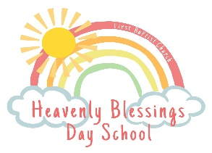
Supply List

Please remember to LABEL EVERYTHING! HBDS will supply nap mats.

2’s
Items to send daily:
*Water bottle
*Lunch & Lunch kit
*Backpack large enough to hold papers and lunch kit
Items to Keep at School:
*Diapers/Wipes/Diaper cream (if necessary) *Extra Clothes/Shoes
*Medications (Release required) *Blanket (optional)

********************************************************************************
3’s & Up
Items to send daily:
*Water bottle
*Lunch & Lunch Kit
*Backpack large enough to hold papers and lunch kit

Items to keep at School:
*Extra clothes/underwear/socks
*Medications (Release required)
*Blanket (optional)

