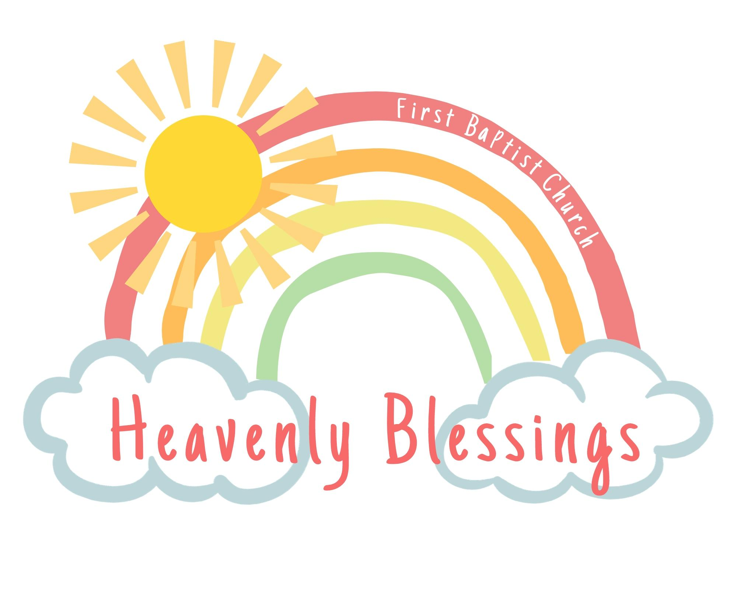

2023-2024
Calendar

August 22-24 Teacher In-Service Days

August 24 Meet the Teacher

August 29 First Day of School

October 10-13 Fall Break

November 21-24 Thanksgiving Break

December 20 Last Day of the Semester (No Stay and Play)

December 21- Jan 9 Christmas Break

January 9 Teacher In-Service

January 10 Classes Resume

February 20-23 Break

March 12-15 Spring Break

May 16 Last Day of School

*HBDS follows the NISD calendar. Dates may be subject to change pending staffing availability*

