**Heavenly Blessings Day School @ First Baptist Church**

**Program and Policies Parent Handbook**

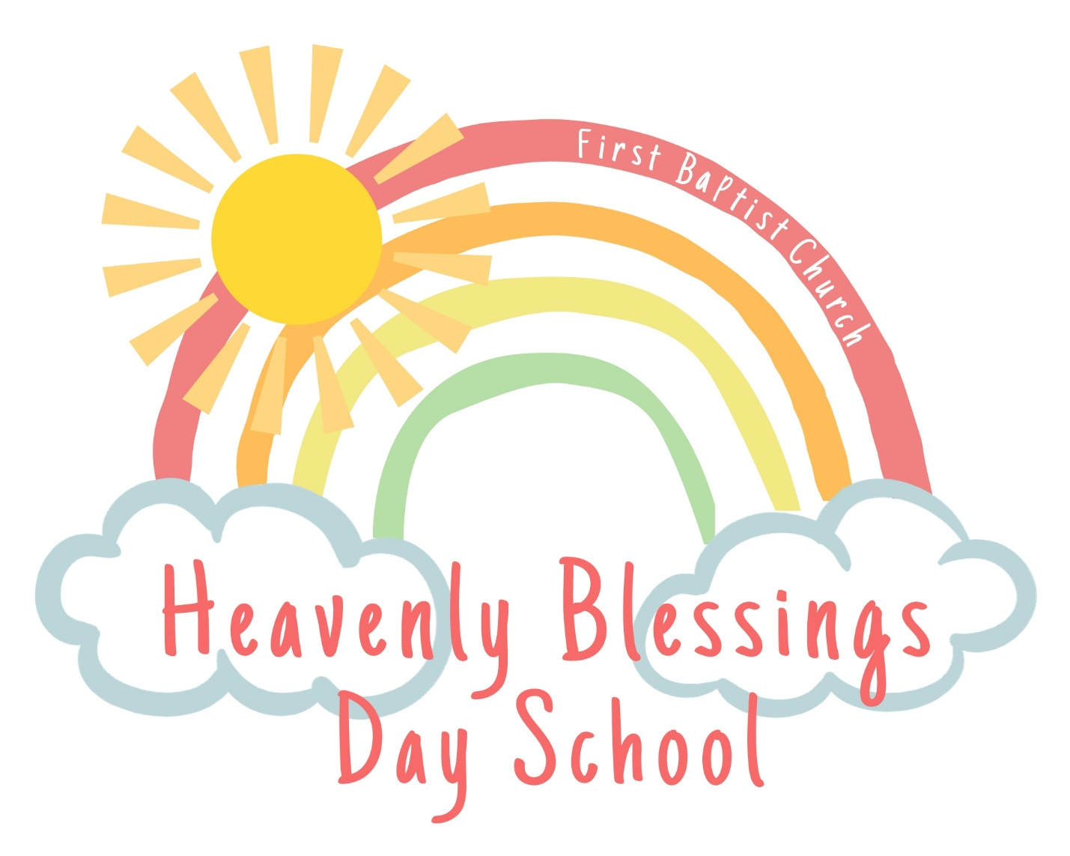

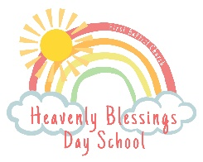Heavenly Blessings Day School

@ First Baptist Church – Navasota, Texas

Program and Policies Parent Handbook

**Purpose**

This handbook’s purpose is to inform parents of school policies and program information. Parents will be given a new copy each year and will be informed of changes to policy in writing when they occur throughout the year. ***Parents are expected to read and be familiar with the document’s information, and the document serves as the parent contract.*** The “Acknowledgement of Programs and Policies Handbook,” which is the last page of this document, must be signed and returned by the first day of enrollment.

**Statement of Mission and Vision**

**Mission**

The mission of Heavenly Blessings is to provide a safe and loving environment where children grow solid spiritual and educational foundations.

**Vision**

We will provide interactions with students and their parents which display Christ-like characteristics.

We will provide a variety of age-appropriate developmental activities that allow children to explore, play, and learn creatively and at their own pace.

We will provide and establish solid policies and procedures that will allow for smooth operations and a safe environment for staff and students.

We will provide interactions and activities designed to develop children’s self-esteem and a positive feeling towards learning.

We will encourage each child to solve problems independently.

We will promote physical development through fine and gross motor practice.

**Philosophy**

Early childhood is one of the most influential times in a person’s development. Young children learn by doing. They need firsthand experiences that provide them with opportunities to explore, question and learn. Activities will center around concrete materials and equipment, such as blocks, water, sand, puzzles, instruments, gardening, rich literacy experiences and visitors to the classroom. As children progress through the program, their use of materials will allow them to deepen their learning and build solid foundations for their future.

**Curriculum**

Heavenly Blessings is a structured program that fulfills the needs of our children in developmentally appropriate ways. We use thematic units and literature to guide our lessons and refer to the Texas Essential Knowledge and Skills to drive our planning. Our program includes biblical stories, prayer, language experiences, art, music, manipulatives, dramatic play, science, nature, literature, cooking, sensory experiences, and more. Any movie shown will be tied to instruction and no longer than 30 minutes. Physical activity will include both structured and unstructured play. We will plan for 60 minutes of vigorous activity (in the classroom and outside) every day. In the event of inclement weather, we will utilize open indoor space and designated indoor active play materials. Activity Plans for the week will be posted outside of each classroom.

If your child has special needs we will provide accommodations and use equipment suggested by health care professionals or other interventionists. Our campus is open to early interventionists or other qualified service providers with parental request and approval. All children will be included in our daily activities, and care givers will adapt their equipment, procedures and vary methods used as necessary to ensure that children are cared for in a natural environment.

**Registration**

There will be a **yearly** **registration fee of** **$130** **for** **students.** This fee is non-refundable, non-transferable, and it is due at the time of acceptance to secure your child’s spot. If we at capacity and are unable to place your child into our program, you may be placed on a waiting list.

Child day care operations are public accommodations under the Americans with Disabilities Act (ADA), Title III. If you believe that such an operation may be practicing discrimination in violation of Title III, you may call the ADA information Line at (800) 514-0301 (voice) or (800) 514-0338 (TTY)

**Tuition**

2’s & 3’s Tuesday – Thursday 8:30-12:30 $265.00 per month

Pre-K Tuesday – Thursday 8:30-12:30 $275.00 per month

Stay and Play is available T, W, Th until 2:30 at an additional $10.00 per day.

Tuition is due the **10th** of the month and will be considered delinquent **after the 10th**. A late fee of **$15** will then be added to your account for the month.

**Payments in the form of a check, credit card, or money order may be made to FBC Navasota or via the payment portal on the website each month. *WE WILL NOT ACCEPT CASH PAYMENTS*. You will be required to pay the necessary amount on any returned check that causes a charge to Heavenly Blessings.**

A 10% sibling discount will be automatically applied. Scholarships are available. Please contact the director to apply.

**Absences**

When your child is enrolled in our center, he/she takes up a reserved slot that is held open. Our expenses remain the same whether your child is here or not. **Unfortunately, there are not refunds or make-up days for missed days.** Consistent and prompt attendance is encouraged. If for any reason your child is late, absent, or out for an extended amount of time, please contact the office.

**Withdrawal/Suspension/Dismissal**

We ask for a **two-week written notice** if a child must be withdrawn for any reason. Failure to do so will result in a two-week tuition charge. While it is always regrettable to dismiss a child from Heavenly Blessings, there are times when such action is appropriate and necessary.

**Some situations demanding suspension or dismissal are:**

1. Non-payment of tuition or fees. If payment is delinquent, children will not be admitted to Heavenly Blessings until tuition is up to date. If tuition is more than two weeks late, the director reserves the right to withdraw the student from Heavenly Blessings.
2. If teachers and parents are not able to stop a child who is biting or hurting other children or continually disrespecting a classroom (see biting policy).

**To avoid suspension or dismissal:**

* Parents will be notified through notes and phone calls.
* A conference held with parents and teachers to set up a plan to deal with inappropriate behavior.
* The child will be suspended or dismissed when no improvement is seen within a certain period of time set up by the director, teachers, and parents.

**Arrival/Pick-Up**

**Arrival**

Parents have the option of walking their child into the building or dropping off in the drive through lane. **If you chose to walk your child in, please park on the street** and use caution crossing in front of drive through traffic. **Do not block the drive through lane during arrival times.**

A greeter will be stationed at the door from 8:25am-8:40am. It is in your child’s best interest to arrive on time to school. Keeping a structured routine helps your child be successful in the classroom and helps teachers ensure that all students participate in lessons and activities.

**Pick-Up**

Children **MUST** be picked up by a parent or an authorized adult. **For each person who is allowed to pick up your child, we MUST have a record of the identity of the person on file. Written notice of changes to this agreement must be signed by the parent(s) and submitted to the director.**

Students who are not participating in our Stay and Play program should be picked up between **12:25pm and 12:35pm. Students who are not picked up by 12:35pm will be charged a late fee of $1.00 per minute.**

Stay and Play students can be picked up any time between 12:30pm and 2:30pm. Before 2:30pm, please ring the doorbell for admission into the building. **Students who are not picked up by 2:35pm will be charged a late fee of $1.00 per minute.**

**Guidance and Discipline Policies at Heavenly Blessings**

**Our discipline policy is built on mutual trust, with teachers and parents working together to help children grow and mature.**

During the early childhood years, children are learning to control their behavior and obey those in authority. It is our belief that consistent, easy-to-understand limits are established and implemented by teachers. By responding to inappropriate behaviors with insight, sensitivity, love, and skill, children will learn positive ways to address their behavior towards each other and adults. When clear, consistent, and age-appropriate limits are present, children increasingly mature and are prepared to learn.

**Techniques to Avoid Problems:**

1. We will use positive statements in giving directions to behavior.
2. We will redirect unacceptable behavior consistently while meeting each child’s needs.
3. We will give the child opportunities to make choices and solve problems.
4. We will give timely suggestions to students to prevent conflict.

**Childishness or Rebellion?**

1. *Childishness is forgetting the rules and not thinking ahead.*

Children are reminded several times and then sit in time out for a short time until they remember the rules and comply “quickly”.

1. *Rebellion is knowing something is wrong and refusing to do the right thing.*

The consequences are time out. The purpose is to help the child have a change of heart. This usually happens in a short time, 1-4 minutes. Outdoor playtime will not be withheld as a consequence unless the behavior happened outside.

**Responsibility**

God has charged parents with the responsibility of both teaching their child what is right and wrong and training them in wisdom. We are privileged that you chose Heavenly Blessings to partner with you in those hours that you are unable to be with your child. While on campus, it is expected that all adults, including parents, treat children and staff with respect. While at Heavenly Blessings, the discipline of children shall primarily be the responsibility of core classroom staff. However, we are a team, and all staff and administrators work together to support the primary teachers in the positive discipline of your child. If you choose to discipline your child while visiting or during dropping off and/or picking up times, it must be done off campus.

**Biting Policy**

We understand that many toddlers go through developmentally appropriate stages of hitting and biting. All employees at Heavenly Blessings, along with parents, will work closely together to resolve these stages while protecting ALL children.

When biting occurs, these important and immediate steps will be taken:

* We will separate the child who bit and the bitten child.
* Staff will say to the child who bit, “We don’t bite each other.” or “I cannot let you hurt other people like that.” The staff will use his/her tone of voice and facial expression to show the child that biting is unacceptable.

Follow up steps include:

* Call an administrator to reinforce “No biting” and call the child’s parents.
* The teacher will carefully supervise to prevent further biting.
* Document the incident and inform both sets of parents of the incident.

We will celebrate many occasions throughout the year. We will have special programs during each semester for parents, friends and grandparents to attend. Information and dates for these events will be shared via the monthly newsletter.

**Outdoor Play & School Delays/Cancellation**

Heavenly Blessings will follow Navasota ISD when making decisions about the school calendar and when delaying or cancelling school due to inclement weather.

It is important for our students to play outside as often as possible. Please dress your child in appropriate clothing for the weather. We use data from local news sources to determine if temperatures are safe to play outside. If the heat index or wind chill is unsafe or uncomfortable, students will play in their designated indoor space.

Heavenly Blessings does not apply sunscreen or insect repellent to children during the school day. You are welcome to apply these before your child comes to school.

**Lost and Found**

Lost articles will be kept in the office. **Any extra items of clothing should be clearly marked with the child’s name, especially jackets.**  The school/church will not be responsible for any item left at the end of each week.

**Clothing & Diapers**

The children at Heavenly Blessings participate in a variety of activities that might get your child a bit messy. We will often use aprons, but your child may come home with some stained or dirty clothing. We ask that your child(ren) wear comfortable clothing for play.

**Please make sure your child(ren) has/have an extra set of seasonal clothes in his/her daily backpack/bag. Please mark the clothing and bag with your child’s name.** Be sure to send a **labeled** jacket when appropriate. Please send your child in suitable shoes. We prefer socks and closed-toe shoes.

**Children in diapers should have several sets of marked clothes and a sufficient supply of disposable diapers for the day. Any diaper cream must be labeled with the child’s name.**

**Lunch**

Your child’s lunch should be something he/she can feed themselves. Keep in mind our teachers encourage the children to eat the “growing food” first and then dessert. Please pack a lunch that includes a variety of healthy foods (protein, dairy, vegetables, fruit and grains). Children will not be allowed to share lunches. For your child’s safety, we ask that you do not send gum or candy. We always aim to make lunch an enjoyable time for your child. Lunch times are posted on the activity plans outside of your child’s classroom. Please have your child’s lunch available by this time **(PLEASE LABEL YOUR CHILD’S LUNCH BAG OR LUNCH BOX/KIT.)**

**Snacks**

Heavenly Blessings will provide morning and afternoon snacks for all children. This includes a variety of food items and water. The snack schedule will be posted on the bulletin board outside of your child’s classroom.

**Birthdays/Celebrations**

Every child loves to celebrate his/her birthday. If you would like your child to celebrate his/her birthday at school, please notify the child’s teacher and verify a date at least a week in advance. Please send easy to handle refreshments (cookies or mini cupcakes work great!). If you send invitations to school, please send enough so that each child in the class may receive one; otherwise please mail invitations.

**Field Trips**

Field trips will be pre-planned and announced at least a week ahead of time. In order for a child to participate, the permission sheet must be signed and the cost of the trip paid. Parents will be asked to provide transportation to and from the field trip unless it is within walking distance.

**Sprinkler Play**

There may be times when we take the children outside for water activities, such as sprinkler play and water tables. No child will have access to the sprinkler play equipment at any time, nor will anyone play on concrete. Sprinkler play will only occur in grass.

**Animals**

Should animals be onsite for an educational experience, parents will be informed in writing and must grant permission for their child to participate.

**Procedures for Parental Visits/Participation**

Heavenly Blessings has an “Open Door Policy” with parents. You may visit the center at any time to observe your child. If you would like a meeting with a teacher or director to discuss your child, please call in advance and schedule a visit.

**Transportation**

Permission for emergency transportation **MUST** be given on the Admissions form.

When loading and unloading children the following guidelines are followed:

1. Children are always loaded and unloaded in a protected area or driveway and will exit on the curbside.
2. Children are accompanied by an adult before entering or after exiting the vehicle. They are not allowed to cross a street without adult supervision.
3. All children are accounted for before leaving the vehicle unattended to ensure that no child is left behind.

Safety restraint:

1. Every child must sit in an infant safety seat, rear facing convertible child safety seat, forward facing child safety seat, child booster seat, safety vest, harness or a safety belt depending on the child’s age, height, and weight. These will be supplied and installed by the parent.
2. No child is allowed to ride in the front seat of the vehicle for any reason.

**Pictures**

Photographs of the children will be taken from time to time under the supervision of the director and staff. These photos may appear on the bulletin board, in newsletters, Facebook, or on our website. If for some reason you do not wish to give permission, please state that on the admission form.

**\*Health\***

**All children must have a current medical examination upon enrollment and their immunizations must be current**. **A copy of your child’s immunization record should be attached to the admission form**. This is to conform to the laws of the State of Texas and Department of Human Services. Documentation must be submitted by the first day of attendance. By **state law, ALL FOUR YEAR OLDS must have a vision and hearing screening prior to the completion before the first semester of enrollment.**

Adequate records of such exam by your health care professional must be provided. Please inform the director and your child’s teacher of any chronic medical problems or allergies before his/her first day of school. Any emergency treatment authorization must be on file for each child (on admission form).

**Keep your child at home if he/she:**

1. has a temperature of more than 100 degrees Fahrenheit in the morning. Children should be free of fever for 24 hours (without medication) before returning to school.
2. has conjunctivitis, an eye infection commonly referred to as pink eye. The eye is generally red with some burning and there is think yellow drainage being secreted.
3. has bronchitis. This can begin with hoarseness, cough, and a slight elevation in temperature. The cough may be dry and painful, but it gradually becomes more productive.
4. has a rash that you cannot identify or have not been diagnosed by a physician.
5. has impetigo of the skin. Shows up as red pimples which eventually become small vesicles surrounded by a reddened area. When the blister breaks, the surface is raw and weeping.
6. has diarrhea (watery or greenish bowel movements that look different or are much more frequent than usual). Child must be free of diarrhea for 24 hours before returning.
7. is vomiting (more than the usual spit up in a baby). Child must not have vomited in the last 24 hours.
8. has a severe cold with fever, sneezing, and nose drainage.
9. seems really sick without obvious symptoms. In this case, a child may look or act different. There may be unusual paleness, irritability, unusual tiredness, or lack of interest.
10. has any contagious disease – measles (Red or German), chicken pox, mumps, roseola, etc. Please let us know if your child becomes ill with a communicable disease so that other parents and the state health department may be notified.
11. has been diagnosed by a doctor as having an ear or throat infection until medication has been administered to the child for at least 24 hours.
12. has head lice. A child must be free of head lice/eggs before returning to class. A doctor’s note and assessment by the school will be required upon your child’s return. This also applies to ringworm.
13. has a green and/or dark color nose run. This may indicate an infection, which could spread to others.

**If a condition develops during the day, a parent will be notified and the child must be picked up as soon as possible. A sick child will be attended to and kept comfortable in the office until parents arrive.**

Heavenly Blessings does not require staff to be vaccinated.

**\* Health Checks\***

A daily health check is a quick way for the child-care provider to check a child’s well-being or a change in the child’s health status while at the center. The daily health check will be performed by a trained staff member upon the arrival of each child at the center. It will be determined upon completion of the daily health check by the center’s staff, not the parent/guardian, whether the child remains in care for that day. The daily health check is to be performed in the presence of and before the parent/guardian leaves.

**Preventing Abuse and Neglect**

Our staff is required to attend annual training regarding the prevention, identification and reporting of abuse and neglect. We coordinate with MCH Family Outreach to help increase awareness. Parents can access information regarding this topic by contacting MCH Family Outreach at 979-704-6691. Teachers and parents must report suspected cases of abuse and neglect by reporting online or calling the 24 hour hotline listed at the end of this document.

**Medications**

We will only administer medications that need to be given 3 times a day. We will ONLY administer the 2nd dose. Medications may be administered to children provided the following procedures are adhered to:

* Parents must fill out and sign an **Authorization for Dispensing Medication** form.
* The medication is in the original container labeled with the child’s full name and original labeling.
* Medication must be given to the director upon arrival at school. Medicine can be refrigerated, if required. **DO NOT leave medicine in the child’s bag. All medicine must be brought to the Director’s office.**
* The child must be brought to the Director’s office for administration. The director and teacher and/or two staff members must be present before medicine is administered.
* Both staff members must sign the **Authorization for Dispensing Medication** form each time medicine is administered.

**Accidents**

Parents are notified of any accidents. Always leave a number where you may be reached. Accident reports are filled out by the teacher and witnessed by a staff member. Parents are asked to sign the accident report for proof that you were notified. SAFETY is our number one priority.

**First Aid and Emergency Procedures**

Heavenly Blessings is fully aware of its role in correctly managing situations that require first aid or emergency care. Everyone on staff is certified in CPR and basic first aid. Our staff is also trained in emergency and safety procedures. We practice fire drills and severe weather drills. In the event of an actual emergency, EMS (911) will be called, and first aid protocol followed. Parents are notified by phone at the number specified on the enrollment form.

*IN THE EVENT OF AN ACTUAL EMERGENCY THAT REQUIRES THE SCHOOL TO ABANDON THE ORIGINAL BUILDING, BELOW ARE THE AREAS WE WILL WALK TO. IF THERE IS AN INJURY, THAT CHILD WILL BE CARRIED TO THE FIRST LOCATION, OR, IF NECESSARY, DRIVEN TO THE SECOND.*

**Designated Safe Area:**

North Church parking lot across the street from the day school.

Heavenly Blessings Day School

301 Church Street, Navasota, TX 77868

936-825-6597 ext 105

**Alternate Evacuation Location:**

Frist Presbyterian Church Navasota

302 Nolan St, Navasota, TX 77868

**FOR TORNADOES/SEVERE WEATHER WATCHES AND WARNING PROCEDURES:**

ALL CHILDREN WILL BE MOVED TO EACH CLASSROOM’S DESIGINATED AREA.

**Gang Free Zone**

Heavenly Blessings Day School at FBC Navasota is a gang free zone. Under the Texas Penal Code any area within 1,000 feet of a child -care center is a gang-free zone, where criminal offenses related to organized criminal activity are subject to a harsher penalty.

**Emergency Numbers**

**911**

Police – 936-825-6410

Fire/EMS – 936-825-7388

Poison Control – 1-800-222-1222

Texas Abuse and Neglect Hotline – 1-800-252-5400

**Viewing of Minimum Standard Rules and Licensing Reports**

A copy of the Minimum Standard Rules for Licensed Child-Care Centers and the latest report from the Department of Childcare Licensing is available for viewing in the office.

**State Licensing:**

A copy of our most recent licensing inspection report can be viewed on the bulletin board by our front entrance.

Texas Department of Family and Protective Services

<http://www.dfps.state.tx.us>

(979) 731-0118

**Monitoring Representative: Licensing Supervisor:**

Halle Saxton Mary Becerra, Supervisor

Halle.Saxton@hhs.texas.gov Mary.Becerra@hhs.texas.gov

3000 E. Villa Maria

Bryan, Texas 77803

(979) 731-0119 Office (254) 742-7078 Cell

(979) 339-5952 Fax (254) 742-3886 Office

**Concerns**

If this is the first time your child will experience a preschool environment, your positive attitude will greatly affect the initial adjustment to our center. While most children have little difficulty adjusting to new situations, some do experience teary separations. Reassure him or her of your return and be prompt for pick up. Call the school to check on your child as often as you like. Please remember that a child can sense any reservations on the parent’s part, so a positive attitude must be maintained to assure a smooth transition.

Backpacks should be checked daily for important communications. Parents, please read all notes and newsletters. Parents of two-year olds will be provided a daily record of diaper changes, naps, and activities. We strongly encourage parents to participate and communicate with us.

It is our policy at Heavenly Blessings that each child’s needs are met. If you have any questions or concerns about our program or the care of your child(ren), please feel free to discuss it with the Administration. We strive to make your child’s stay a wonderful experience.

Heavenly Blessings @ First Baptist Church

Acknowledgement of Program and Policies Parent Handbook

I, ______________________________________________, acknowledge that I have received, read, understand, had the opportunity to ask questions about, and agree to follow Heavenly Blessings @ First Baptist Church Program and Policies Parent Handbook. Included in the handbook are policies concerning:

**Discipline and Guidance**

**Suspension and expulsion**

**Emergency plans**

**Procedures for conducting health checks**

**Procedures for parents to discuss concerns with the director**

**Procedures for parents to participate in operation activities**

**Procedures for release of children**

**Illness and exclusion criteria**

**Procedures for dispensing medications**

**Immunization requirements for children**

**Meals and food service practices**

**Procedures to visit the center without securing prior approval**

**Procedures for parents to contact Childcare Licensing (CCL), DFPS, Child Abuse Hotline, and CCL website**

Child’s full name_____________________________________________________

Parent’s Signature/Date_______________________________________________